The King's Speech
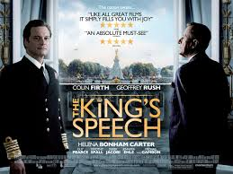
The King's Speech is a 2010 British historical drama film directed by Tom Hooper and written by David Seidler. Colin Firth plays King George VI who, to cope with a stammer, sees Lionel Logue, an Australian speech therapist played by Geoffrey Rush. The men become friends as they work together, and after his brother abdicates the throne, the new King relies on Logue to help him make his first wartime radio broadcast on Britain's declaration of war on Germany in 1939.
This movie in my opinion, deserves to be recognized due to the fact that it is based on real events that happened in the twentieth century.
The film had its world premiere on 6 September 2010 at the Telluride Film Festival in the United States. It was screened at the 2010 Toronto International Film Festival, on Firth's 50th birthday, where it received a standing ovation and won the People's Choice Award.
From the heart I recommend you watch this movie. I give it 9/10

Taken from Wikipedia and adapted by Adrian Kunikowski.

